User Guide For Object Based Image Analysis (OBIA) Software

This document describes the OBIA software developed by the Geomatics Engineering Group, IIT Roorkee. This guide only describes how to use the software, for the details of the theoretical concepts kindly refer to dissertation report by Anshul Gupta.

Team

Dr. Manoj K. Arora
Professor, Department of Civil Engineering
IIT Roorkee

Anshul Gupta
anshul.g08@gmail.com
CSE-IDD
Department of Computer Science, IIT Roorkee

Sangita Singh
singh.sangita15@gmail.com
MTech - Geomatics
Department of Civil Engineering, IIT Roorkee

Overview of Graphical User Interface
This section provides an overview of the GUI designed for the methodology developed. The GUI has been designed and developed in Matlab. The GUI consists of three basic modules,
- Image Visualization Module
- Segmentation Module
- Classification & Attribute Selection Module
The Image Visualization module is used for loading remote sensing images and contains different components which can help a user to better understand and visualize the image. The segmentation module is used for performing Image Segmentation using the region growing and merging method described in section 3.2.2. Lastly Classification & Attribute Selection module is used for performing attribute selection using the CART based method described in section 3.2.3 and classification using Support Vector Machine. The Classification & Attribute Selection module has a limitation that it does not support the hierarchical classification method described in section 3.3.4, it can only perform a straight forward classification using SVM. In the following sections the details of each module have been described in details.
1. Image Visualization Module
The Image Visualization module forms the backbone of the complete software; it is the first window that the user encounters on opening the software. Figure 1 a screen shot the Image Visualization module. The module is split into three sections ,
- Menu bar – Contains options for loading remote sensing image in the module, closing the module and launching the Image Segmentation module. At present only Jpeg, Tiff image are supported in the software.
- Option Pane – Contains two basic options, one for viewing different spectral layers of the image and second for selecting a subset of the image for performing subsequent operations.
- Image Area – This is the area on the window which displays the remote sensing image loaded in the module.

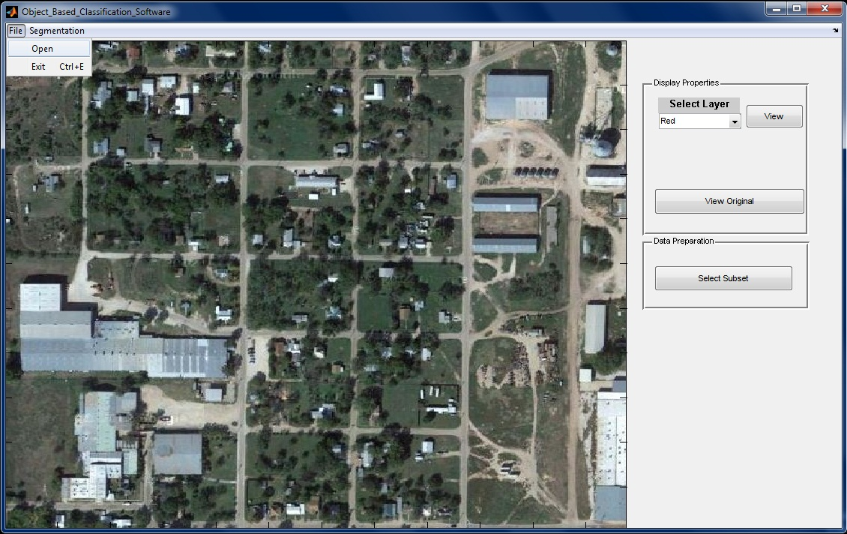
1.
2.
3.
4.
5.
6.
.
7.

1. Menu item for opening the Image Segmentation module
2. Menu item for loading an image
3. Menu item for closing the module
4. Drop down menu for selecting the spectral layer to be viewed
5. Button for displaying the original image
6. Button for selecting subset of the displayed image
7. Area for displaying the image

Figure 1 Image Visualization Module

2. Segmentation Module
The Segmentation module is launched from the Image Visualization module. It is used for performing image segmentation. Figure 2 a screen shot the Segmentation module. The module is split into two sections,
- Option Pane – Contains options for entering scale parameter, save and loading results, zooming in, zooming out, drop down menu for selecting the colour of the segment boundaries and button for launching the Classification & Attribute Selection module.
- Image Area – This is the area on the window which displays the remote sensing image loaded in the module.
1.
2.
3.
4.
5.
6.
7.
8.
9.
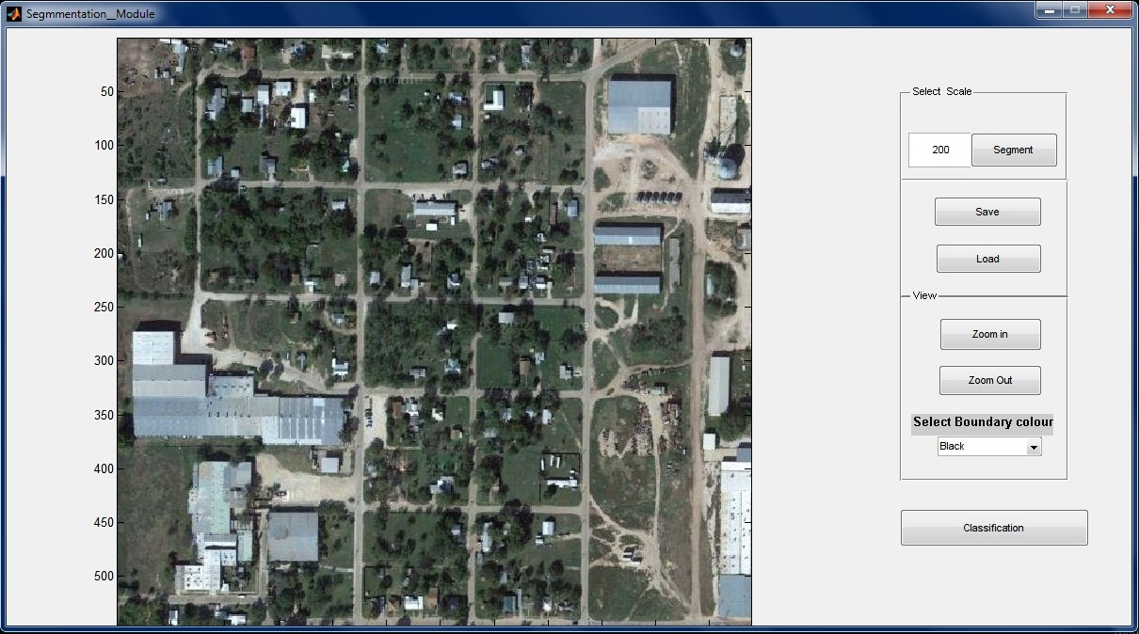
1. Text box for entering scale parameter
2. Button to start segmentation
3. Button for saving the segmented image
4. Button for loading previous results
5. Button for zooming in
6. Button for zooming out
7. Drop down menu for selecting the colour of segment boundaries
8. Button for launching Classification & Attribute Selection module

Figure 2 Segmentation Module
3. Classification & Attribute Selection Module
The Classification & Attribute Selection is for two purposes, first performing attribute selection using CART, second performing segmentation using SVM. Figure 3 shows a screenshot of the module with explanation of different options.
1.
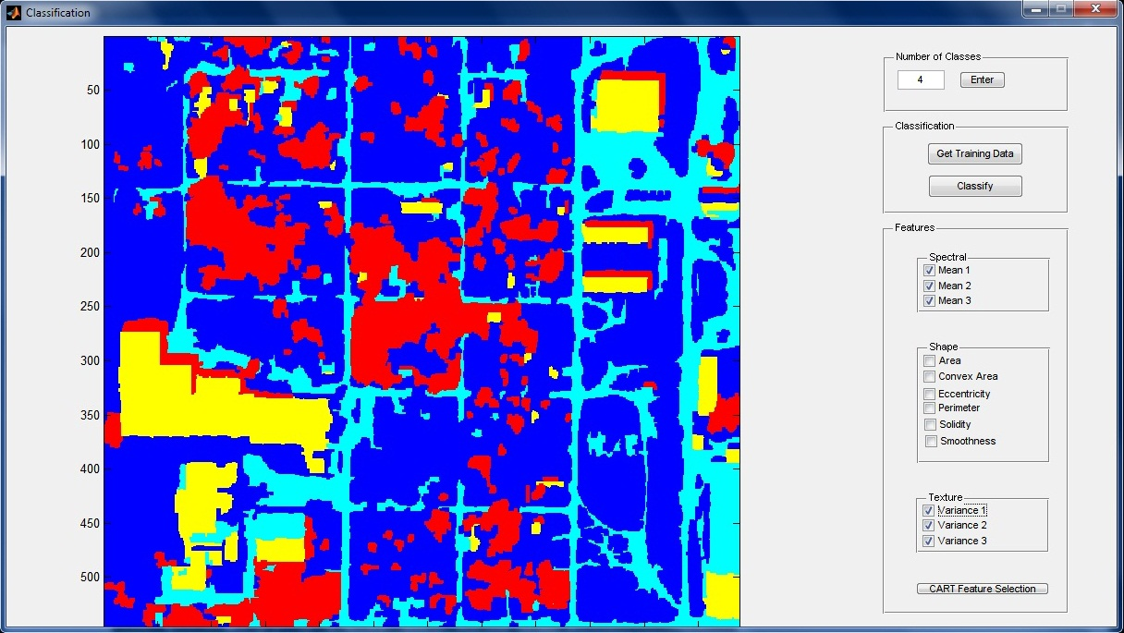
2.
3.
4.
5.
6.
7.

1. Text box for entering number of classes
2. Button to update the number of classes
3. Button to enter training data
4. Button to perform classification
5. Pane showing different attributes used for classification
6. Button to perform attribute selection
7. Area for displaying classified image

Figure 3 Classification & Attribute Selection Module

On the training data button, the mouse arrow changes to cross arrow using which the user can interactively select the segments which are to be given as input data for a particular class. The different attributes present the attribute pane can be selected or deselected manually by clicking on the checkbox in front of the corresponding attribute. After clicking on the CART Feature Selection button, a decision tree is built the selected attributes are automatically checked. Figure 4 shows a windows displaying decision tree produced by CART.
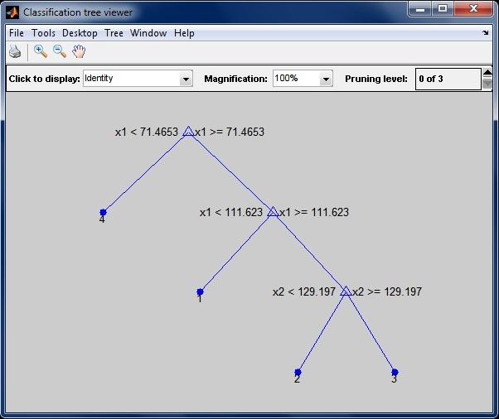

Figure 4 Window Showing Decision Tree Produced By CART

Typical Workflow

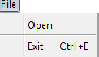
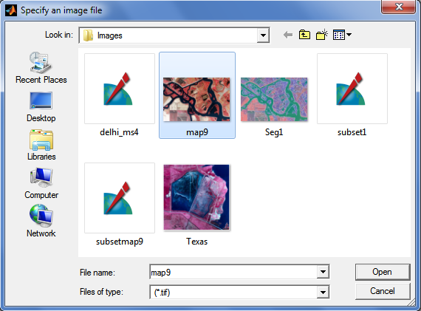
1 Open an image : File-Open-Choose a file name

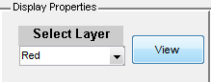
2. To view the image as layers: ‘Select Layer’ then click ‘View’

3. To create subset: ‘Select Subset’ and select the area of interest from the image by clicking.

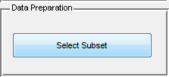
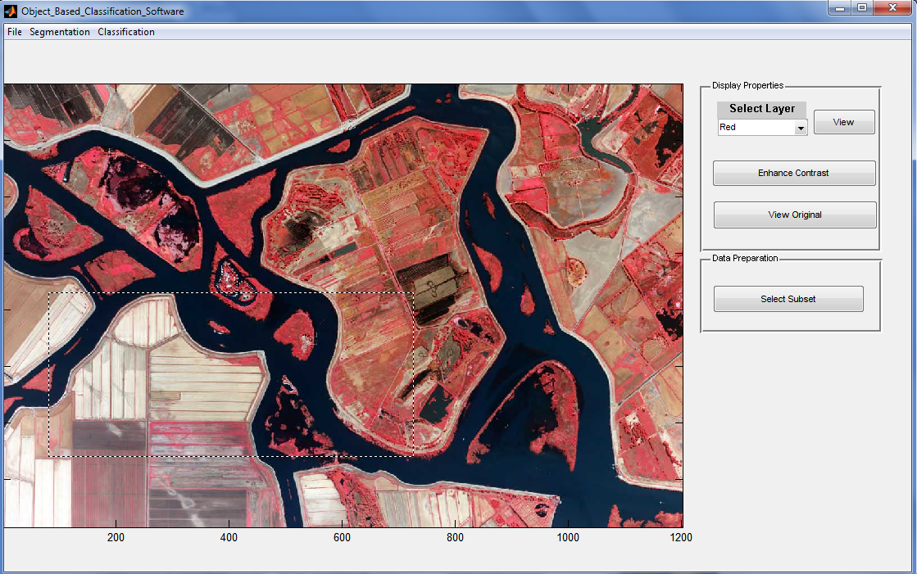
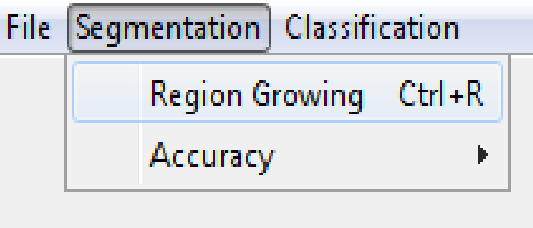
- To segment the image: Segmentation-Region Growing

- Enter the scale parameter and click Segment. Also change the boundary colour by clicking ‘Select Boundary Colour’
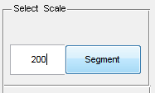

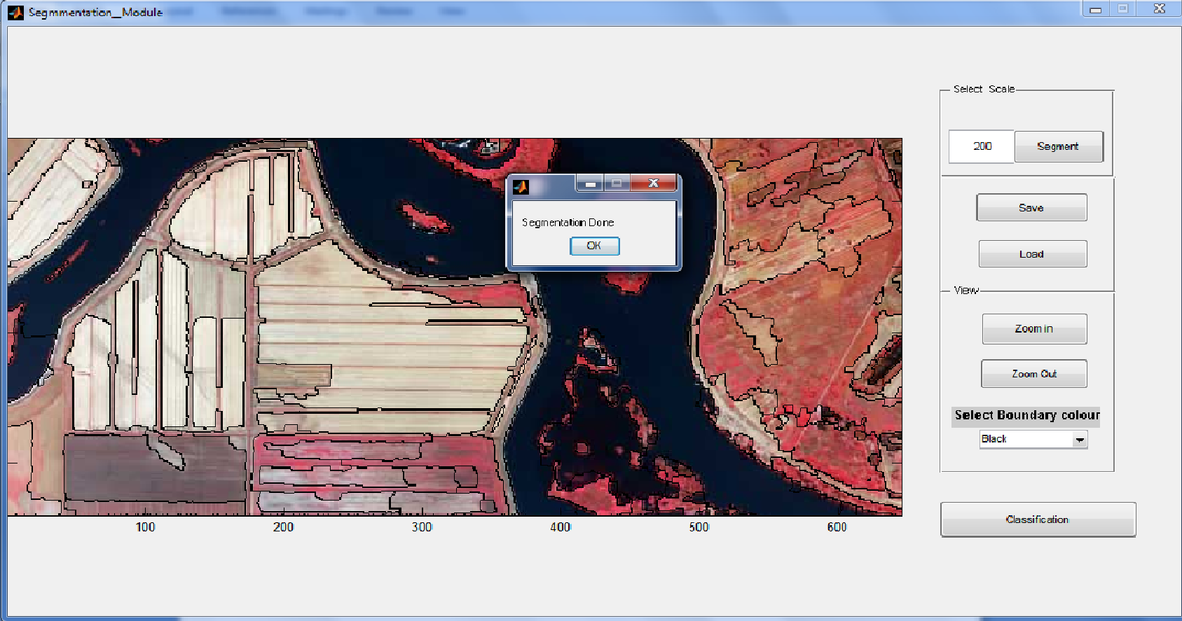
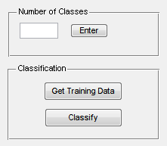
- To Classify the Image: Click ‘Classify’ Button. A new Window opens. Enter the number of classes in the classified image and click ‘Enter’.

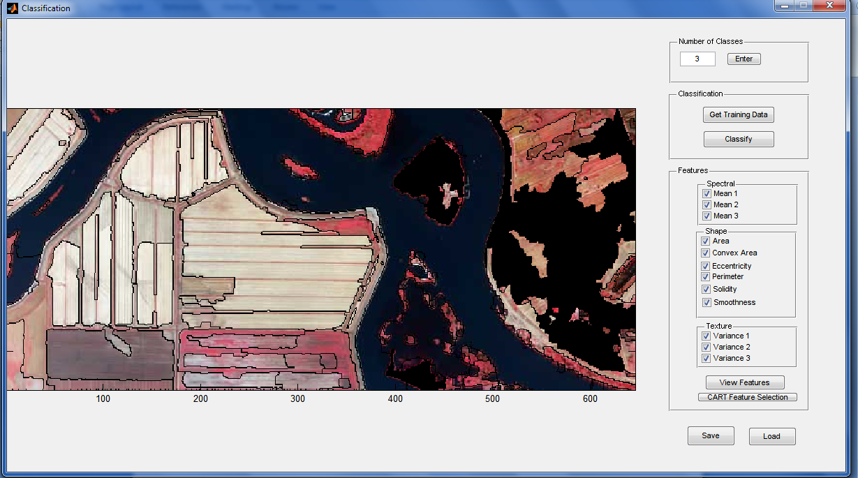
  - Click ‘Get Training Data’. Click on regions for each class followed by pressing ENTER key. The selected area will appear darkened (black) as shown in the figure.

  - For selection of features: Click ‘CART Feature Selection’. Selected features will appear as shown
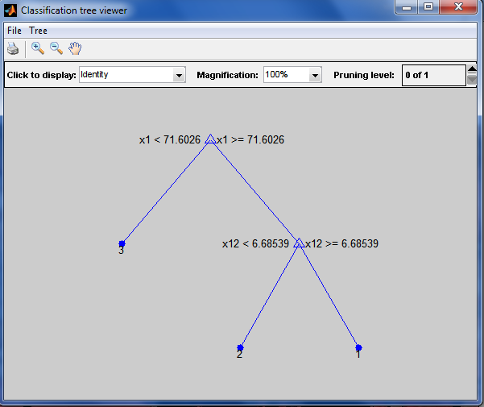
  - To get the classified image Click ‘Classify’

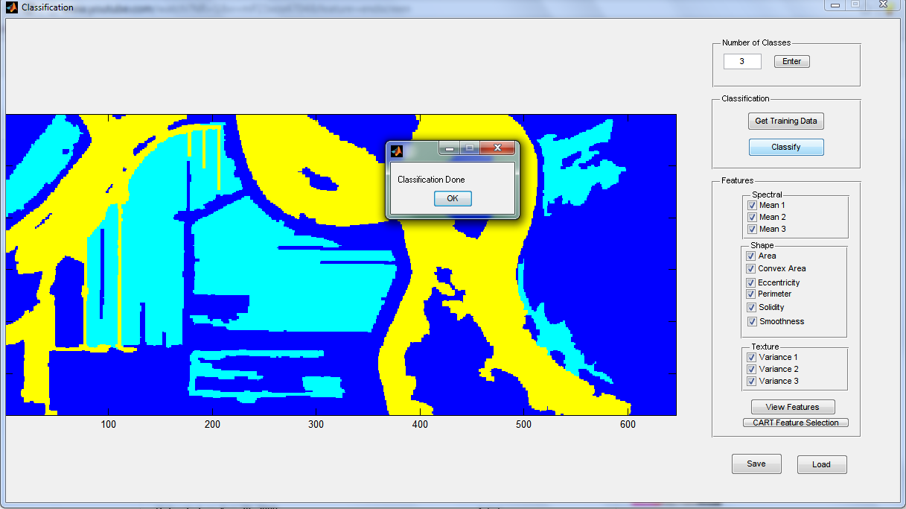
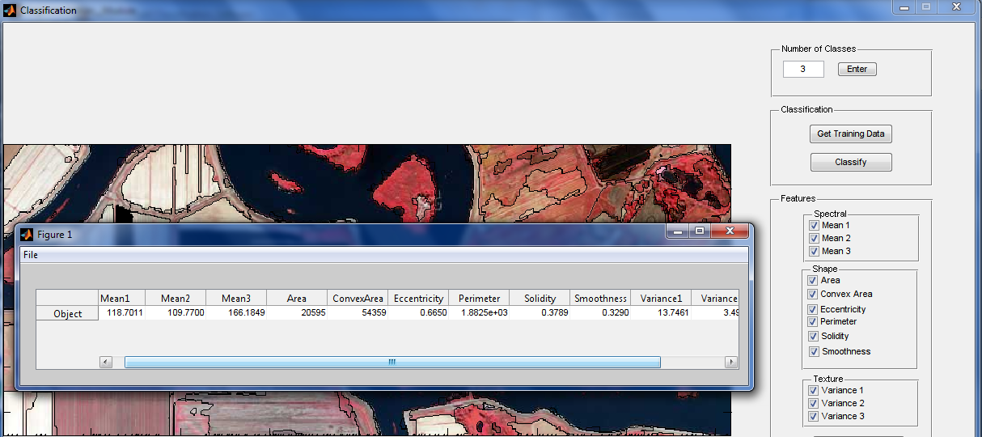
  - To view feature for a selected segment: Click ‘View Features’

